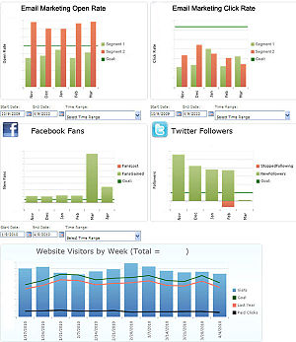 v

Motor SQL Server

.NET Framework 4.0

MVC – Poncho ( Bootstrap )

Servicios REST Json

Motor PostgreSQL

Motor PostgreSQL

Motor PostgreSQL

**SGE Provincias**

**SINIDE_DW_V01**

**Arsat - EducAr**

**SINIDE 1.0**

**SGE**